**Efficient Organ Transplantation using data analysis and modified real-time traffic signal optimization for Fast Organ Transportation**

Pratik Basu (pratik.basu191@gmail.com) Sobhan Mondal (sobhaniiest@gmail.com)

**INTRODUCTION:**

Organ transplantation in India comes with a varied number of unwanted discrepancies. Lack of an efficient centralized system to generate potential matches in real-time has been a serious problem. In fact further integral issues like transport and traffic congestions pose a major threat to successful transplantations in a diverse country like India.

A successful transplant is largely dependent on the accuracy of the collected data and how well and how efficiently the data fits in with urgency. Further, apart from the medical aspect of exact data matching; comes the hurdle of the traffic system in India that, to an extent, dictates the overall time required for transportation. This elapsed time is therefore a necessity to be minimized in order to ensure that operating time is optimum.

The model we propose is a suggested modification to the existing traffic system, particularly in cities like Kolkata, where the traffic signal timer is predefined using timer circuits. Our model suggests that the signal timers must be replaced using microprocessors connected to sensors that will track real-time vehicular distance and thereby automatically self-adjust the timers depending on the presence or absence of emergencies like the approach of ambulances, etc.

We further suggest that a recipient-donor data match can be more accurately and dynamically identified if a detailed analysis is conducted on the data already present over decades and thereby predicting a correct match considering various factors ranging from medical data to urgency, geography and other related metadata using specific machine learning traits. After a match is obtained; we propose to implement the modified traffic system for transportation as a boost to the elapsed time.

Another crucial aspect of our model is the use of a shortest path algorithm to ascertain the least time and shortest path required to reach the destination hospital. This particular step is implemented by chalking out a graphical analogy to the actual map of a desired area taking into account each traffic signal and potential hospitals as nodes and thereby applying Dijkstra’s algorithm. Finally, the proposed modified traffic architecture is made use of to ensure the ambulance, or the vehicle transporting the organ, can fluently navigate through the traffic with the least amount of discrepancy.

Hence, an efficient route tracking architecture coupled with proper statistical and data analysis systems can surely help a developing country like India to tackle more crucial situations with efficiency and rapidity thereby smoothly tackling these emergencies. A successful transplant can save a precious soul from the drowning doors; through our model we believe we can save a million more.

**The goal of our project is to** –

Locatecases of immediate transplantation due to accident or any other incident –

Search the database & match which closest donor

Our implementation is based on the following methodologies:

1. To host aninterlinked database for all the hospitals (data of donor and recipient).
2. Statistical Data Analysis to sort out potential donor-recipient matches.
3. A GPS system to track the possible routes among the potential matches.
4. Real-time traffic signal optimization
5. Dijkstra’s Algorithm to find the shortest path from the donor hospital to acceptor hospital.

**IMPLEMENTATION:**

Flowchart of our Implementation

Hosting the Database

Data Analysis

Matching the Donor-Recipient

Dijkstra’s Algorithm for Shortest Path

Tracking System based on GPS

Real-Time Traffic Signal Optimization

* **Hosting the Database**

The first step of our suggested model is about data collection and hosting it on an interlinked database to genuine registered hospitals having a sound history of successful transplantations. The database consists of medical data collected from all the possible hospitals. The various parameters necessary for a transplant is managed under a well organized constructed dataset with the scope of real-time update and modification of data based on fresh entries or unwanted scrap data. The centralized database is like a cloud storage that can be easily accessed from all the concerned hospitals in case of emergency and desired needs and updated under authorized access protocols. This dataset acts as a tool or a precursor to the step where the data is analyzed as required using various algorithms so as to ensure the best match with the most efficient techniques to ensure minimum casualties and successful and fast organ transplantation on a global scale.

* **Data Analysis using Machine Learning Algorithms**

This step is largely dependent on the database collected and maintained. Based on the data, various algorithms and optimization techniques can be incorporated so as to derive the best possible donor-recipient match in accordance to predefined results and outcomes. Our suggested method to perform such analysis is by using supervised learning algorithms and neural networks on the already present dataset and predicting the most accurate match for new cases. We divide the dataset under scrutiny into 60%, 20%, 20% subsets. A randomly chosen 60% of the dataset is assigned as our training set on which different parameters like medical history, transplant behaviors and other similar data can be used to train our system. Now the next 20% data is used as a cross validation step to cross verify and perform required modifications on our used algorithm or approach so as to ensure maximum precision. Finally, the remaining 20% data is used as a test set. The prediction results of these test cases are closely monitored with the results with our train set and thereby respective accuracies with various algorithms are noted. Finally the best possible approach with the most efficient time complexity is chosen as the best technique to analyze the dataset in real-time.

In case of actual emergencies the opted matching technique can be easily incorporated in the final model and thereby reduce erroneous data matching to the best possible extent.

* **Tracking System based on GPS and physical traffic data**

This step is the pivotal step after the data analysis is done and possible donor-recipient matches are located. The use of the Global Positioning System and reliable physical roadside data is made to track all possible routes to the selected hospitals with potential matches and create a weighted graph with several nodes. This derived weighed graph (with the weights denoting respective path lengths) is now processed through a shortest path algorithm to find the shortest possible route to the best match.

* **Shortest path algorithm to track the nearest hospital**

This step of our framework is utilized to determine the minimum and most effective route for organ transport. Suppose we find out that ‘n’ number of roads with minimum traffic congestion to the target hospitals ispossible through data analysis and aforementionedtracking procedure. The task now is to find the shortest route among the best possible ‘n’ options to reach the desired location with minimum delay.

To achieve this, Dijkstra’s algorithm is used.

We first construct a directed graph with the donor hospital marked as the source vertex. We then design the graph with each traffic signaland potential hospitals (with donation possible or not marked distinctly based on real-time analysis) as individual nodes by assigning each edge with their distances (extracted from GPS data). The hospitals are denoted by nodes represented by Ni and Pi. Based on data analysis and trafficroutes we find the hospitals denoted by Pi as the potential donor hospitals. Finally, we apply Dijkstra’s Algorithm to find the shortest path from the potential donor hospitals to the recipient (source vertex) hospital and decide the fastest route to the nearest hospital.

Below is a sample implementation of our suggested idea:

After applying the algorithm on the following sample, we find that **Hospital: P3** has the fastest route to the recipient**Hospital:S**.

(The fastest route has been indicated by red colour)

(Mentioned weights/distances are just for representational purposes)

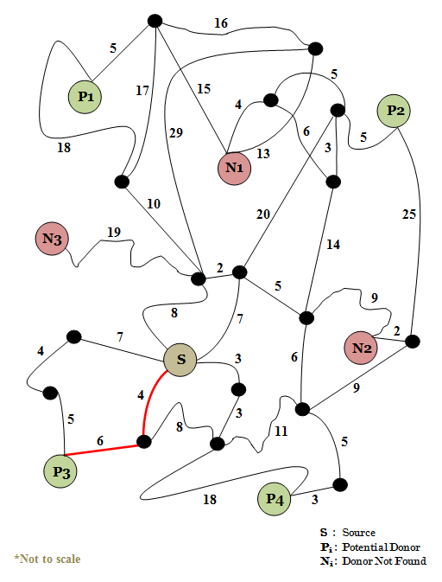

* **Real-time Traffic Signal Time reduction(Creating Green Corridors Automatically )**

Usually in India the traffic signals are manually operated to avoid stoppage at red lights and to divert the traffic to ensure a rapid transportation of the desired organ.

This step of our framework is a suggested modification to the already existing traffic system so that the Green Corridors forms without human involvement. It is based on the implementation of the previous step to obtain the shortest route among all possible hospitals. The main target is an attempt to dynamically optimize the traffic signaling through real-time vehicular tracking through GPS. As soon as the selected route is finalized, the transport is executed such that the traffic throughout the whole process stays green.

The suggested idea is that, as and when an ambulance reaches a specific distance (say, ‘D’) from a signal, two of the following cases may arise-

* If the signal is already green and the ambulance being at a distance-‘d’ (d<D) from the signal, after completing the green signal duration (default time) when the signal is going to turn red; then the time elapsed for the red to revert back to green is reduced and the next green signal stays for a longer duration to ensure uninterrupted passage.
* If the signal is already red, after completing the red signal duration (default time) when the signal is going to turn green; the green signal stays for a longer duration.
* All the signals at a crossing will change accordingly the pivotal signal (signal on the green corridor).

The suggested architecture can be incorporated real-time by replacing the present predefined timer based IC controlled traffic system to a microcontroller based system.

Smart Traffic Signal

**Flowchart of Real-time Traffic Signal Time reduction**

Transmitting the data to the signals to change or update the sequence and duration of signalling according to the algorithm

Track the ambulance and transmit the updated data to the ambulance

Find and update the new shortest path

Yes

Are there any accidental situations on the transportation path?

Observe the transportation path

**Cloud Network**

Smart Ambulance

Real time distance measurement of the ambulance from a particular signal

**Following is an example to demonstrate the idea on a small dataset:**

**First case:**

* The first ten columns, Di (i varies from 1 to 10, considering 10 traffic signal points) shows the distance from a particular signal ‘i’ from the ambulance at each instance. The next 10 columns Si shows the signal state (green/red) and the corresponding signal durations for specific instants. The last column shows the time in seconds.
* 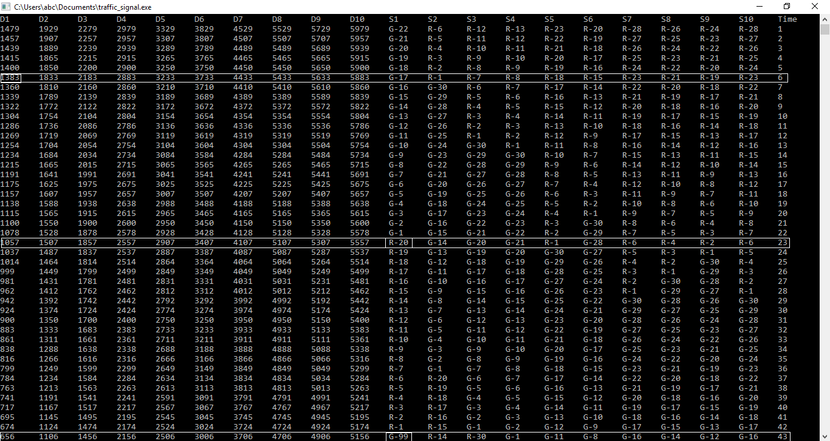Assuming that D = 1400 being the predefined range from every signal to the ambulance distance at a concerned instant.
* The first highlighted box shows that the distance from the first signal is 1383 at time 6 secs. The distance is now clearly within the predefined range (1400), so the state of the first signal is modified accordingly. The signal before the ambulance reached within the range of 1400 was green; we the wait for the signal to revert back to red within the time-frame before it crosses the signal.
* Our suggested algorithm now reduces the signal duration of red (from 30 secs to 20 secs) accordingly such that there is minimum time lag for the ambulance waiting time at the signal under investigation shown in the second highlighted box.
* The third highlighted box shows that after the red signal duration is reduced the following green signal elapsed time is increased (by 100 secs) so as to ensure uninterrupted passage with minimum time delay through the first signal.

**Second Case:**

* The first highlighted box shows that the distance from the sixth signal is 1398 at time 126 secs. The distance is now clearly within the predefined range (1400), so the state of the first signal is modified accordingly. The signal before the ambulance reached within the range of 1400 was red; the following green signal time elapsed will be increased (by 100 secs) such that the ambulance passes the sixth signal smoothly.

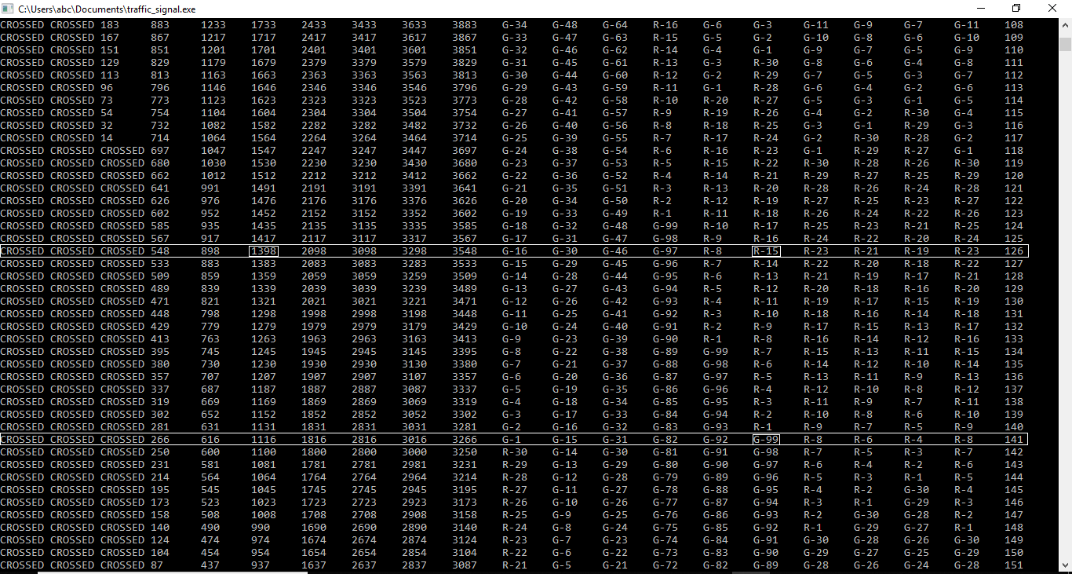

The simulation results analyzed above matches with our proposed model that as and when the ambulance traverses a particular signal; the algorithm **ensures that it stays green** and there’s no time delay as well as not compromising with the traffic hassles at that instant.

**CONCLUSION:**

A successful transplant can save a precious soul from the drowning doors; through our model we believe we can save a million more. Further, this type of traffic optimization technique can be incorporated to tackle for various day-to-day issues like fire fighting and similar urgent situations requiring immediate maneuvering through the busy roads efficiently.

**LINK TO OUR CODES:**

* https://github.com/Pratsbas123/Fast-Transplant/blob/master/.gitignore/Dijkstra.cpp
* https://github.com/Pratsbas123/Fast-Transplant/blob/master/.gitignore/Traffic_signal.cpp